Post-Quantum Security for Artemis zkML

No. | Query
1 | Among FRI, Poseidon, ML-DSA, SLH-DSA, ML-KEM: why and why not are you using a given quantum-safe solution? A comparative study should justify the choice.
2 | You already mentioned zk-STARKs, so why not integrate it with Artemis instead of trying a new solution?
3 | How are you going to build the setup that demonstrates robustness against quantum attacks? What performance parameters will you use? What alternative solutions will you compare against?
4 | How can hash based commitments be used instead of ECC from a functionality and usability point of view?

Query 1
Among FRI, Poseidon, ML-DSA, SLH-DSA, ML-KEM: why and why not are you using a given quantum-safe solution?
The Core Issue: Not All Solutions Solve the Same Problem
The solutions listed above belong to different groups. They are not interchangeable. Before choosing one, it is important to understand what Artemis actually needs.
Artemis needs a polynomial commitment tool. This is a tool that allows a model owner to lock in the value of a polynomial (which encodes the model weights) and later prove to a verifier that the polynomial gives a specific result at a specific point. This is exactly what KZG does today. Any replacement must be able to do the same job.
Categorising All Solutions
Solution | Type | What It Does | Can It Replace KZG in Artemis? Why or Why Not?
ML-KEM  (FIPS 203) | Key Setup Tool | Allows two parties to agree on a shared secret key over a public channel.  Replaces RSA and ECDH for key exchange. | No. Wrong job entirely.  Artemis does not do key exchange at any point.  KZG is used to commit to model weights as polynomials and prove evaluations.  ML-KEM cannot commit to polynomials or prove that a polynomial gives a certain value at a point.  Using ML-KEM would be like using a lock to replace a calculator.
ML-DSA  (FIPS 204) | Digital Signature Tool | Allows one party to sign a message so others can verify it came from that person.  Replaces ECDSA. | No. Different job.  A digital signature proves who created a message. It does not commit to polynomial values.  Artemis needs to prove: I know model weight w such that the committed polynomial evaluates to w at a specific point.  ML-DSA proves: I created this message with my private key.  These are completely different operations.  Replacing KZG with ML-DSA would break all proof verification in Artemis.
SLH-DSA  (FIPS 205) | Digital Signature Tool  (Hash-based) | Same job as ML-DSA but uses hash functions instead of lattice math.  Post-quantum safe. | No. Same issue as ML-DSA.  Even though SLH-DSA is hash-based and post-quantum safe, it is still a signature tool.  It signs messages. It cannot commit to polynomials or prove polynomial evaluations.  The five operations Artemis needs (PC.Setup, PC.Commit, PC.Verify, PC.Open, PC.Check) are not supported by SLH-DSA.
Poseidon | Hash Function  (works well inside ZK proofs) | A hash function designed specifically to work efficiently inside ZK proof systems.  Much lighter than SHA-256 when used inside Artemis circuits. | Partial. Not standalone.  Poseidon alone cannot replace KZG. It is a hash function, not a polynomial commitment tool.  However, Poseidon is used as the internal hash function inside FRI.  Together, FRI uses Poseidon as its engine to build a complete polynomial commitment tool.  Poseidon is already referenced in the Artemis paper as the recommended hash for ZK circuits.  This makes our choice of Poseidon directly aligned with the Artemis paper's own design.
FRI | Polynomial Commitment Tool  (Hash-based) | A polynomial commitment tool built entirely on hash functions.  No ECC. No secret setup. | Yes. Direct replacement for KZG.  FRI supports all five operations Artemis needs: PC.Setup, PC.Commit, PC.Verify, PC.Open, PC.Check.  No trusted setup required. No secret number tau. No toxic waste problem.  Security comes from hash collision resistance, not ECC. Shor's algorithm has nothing to attack.  Used in production systems: StarkWare, Stone Prover, zkSync.  Years of independent security analysis available.
Brakedown | Polynomial Commitment Tool  (Hash-based) | Another hash-based polynomial commitment tool.  No trusted setup. Post-quantum safe. | Yes, but less mature than FRI.  Brakedown is a valid alternative to FRI. It can also replace KZG.  However, it has limited production deployments compared to FRI.  FRI has significantly more independent security reviews and real-world use.  For this reason, FRI is the stronger and better-justified choice.

Summary: Why FRI + Poseidon
After categorising all solutions:
- ML-KEM, ML-DSA, SLH-DSA are eliminated because they do a different job. They cannot replace KZG.
- Among tools that can replace KZG (FRI and Brakedown), FRI is chosen because it is more mature, more widely deployed, and has more security analysis.
- Poseidon is chosen as the hash function inside FRI because it works efficiently inside ZK computation circuits (far fewer steps than SHA-256) and is already recommended in the Artemis paper.
The proposed replacement is FRI + Poseidon. FRI does the job that KZG does today (commit to polynomial, prove evaluations, allow verification) but without ECC and without a trusted setup. Poseidon is the hash function that powers FRI from inside, chosen for its efficiency in ZK circuits.

Query 2
You already mentioned zk-STARKs, so why not integrate it with Artemis instead of trying a new solution?
Understanding the Difference
This is an important distinction. zk-STARKs and KZG are not the same type of thing.
KZG is one component inside Artemis. It handles one specific job: committing to polynomials. zk-STARKs is an entire proof system. It replaces the whole architecture of Artemis, not just one part.
Four Reasons Not to Switch Entirely to zk-STARKs
Reason 1: It Requires Rebuilding Artemis from Scratch
Integrating zk-STARKs with Artemis is not a plug-in change. zk-STARKs replace the entire proof architecture including the way computation rules are encoded, how the prover and verifier interact, and how the final proof is generated. All of this would need to be redesigned. The Artemis paper represents years of research. A STARK-based version of Artemis does not exist and would itself be a multi-year research project.
Reason 2: Artemis Was Designed for Exactly This Kind of Targeted Fix
The Artemis paper explicitly states:
"Artemis is compatible with any homomorphic polynomial commitment scheme."
This means the authors of Artemis built in the flexibility to swap out the polynomial commitment tool. Replacing KZG with FRI is precisely the kind of upgrade the paper anticipated. No other part of Artemis needs to change.
Reason 3: Full STARK Migration Has a Serious Performance Cost
Based on a 2025 comparison study (arXiv:2512.10020), when zk-SNARKs and zk-STARKs are run on the same hardware:
Measurement | zk-SNARK (Current Artemis uses this) | zk-STARK (Full switch to this)
Proof generation time | 55 ms  Fast because ECC operations are well optimised | 3,809 ms  68 times slower than SNARK  Heavy polynomial operations cause this
Proof size | 0.6 KB  Very compact, one ECC point per commitment  Low cost to transmit and store | 69 KB  115 times larger than SNARK  Hash paths and proximity proofs add up  High cost for zkML on-chain verification
Verification time | 1,807 ms  Slower due to ECC pairing checks | 472 ms  4 times faster  Hash-based checks are cheaper than ECC pairings
Trusted setup needed? | Yes  Requires tau ceremony before deployment  Any compromise of tau breaks all proofs | No  Fully open setup  Anyone can verify the parameters independently
Post-quantum safe? | No  KZG relies on ECC  Shor's algorithm breaks it completely | Yes  Security from hash collision resistance only  Shor's algorithm has nothing to attack
Protocol redesign needed? | No change  Artemis protocol stays intact  Only the commitment tool is swapped | Full redesign needed  New computation encoding, new prover-verifier flow, new proof format  Years of work

Reason 4: The Targeted Fix Gets the Best of Both
By replacing only KZG with FRI + Poseidon:
- Post-quantum safety is achieved because FRI uses only hash functions
- Proof sizes stay compact because the rest of the Artemis SNARK structure is preserved
- No trusted setup is needed because FRI does not require a secret tau
- The entire Artemis protocol remains unchanged
- Implementation is feasible within the MTP timeframe
Switching entirely to zk-STARKs would mean rebuilding Artemis from scratch, accepting 115 times larger proofs and 68 times slower proof generation, and losing all the optimisations that make Artemis efficient. The targeted fix of replacing only KZG with FRI achieves post-quantum safety while preserving everything good about Artemis.

Query 3
How are you going to build the setup that demonstrates robustness against quantum attacks? What performance parameters will you use? What alternative solutions will you compare against?
Proposed Pipeline
The proposed pipeline is Artemis + FRI + Poseidon. KZG is replaced with FRI as the polynomial commitment scheme, and Poseidon is the hash function inside FRI.
Everything else in Artemis stays unchanged.

Proposed Experimental Setup
Part 1: Show the Vulnerability in the Current System
This part demonstrates that the current KZG commitment in Artemis is vulnerable to a quantum-equivalent attack.
- Build a small ECC curve with reduced parameters (intentionally breakable for demonstration)
- Implement the KZG commitment: C = w . G, where w is a model weight.
- Run Baby-step Giant-step (BSGS) attack. BSGS is the classical equivalent of Shor's algorithm. Both exploit the same ECC group structure. BSGS is used here because Shor's requires quantum hardware not yet available.
- Show BSGS recovers the secret weight w from the public commitment C
- Show that a forged commitment passes the verifier check. This means the Artemis guarantee is broken.
Part 2: Show the Fix Works
This part demonstrates that replacing KZG with a hash-based commitment eliminates the attack.
- Implement hash-based commitment: C = SHA-256(w combined with a nonce)
- Run the exact same BSGS attack on this commitment
- Show BSGS fails. There is no ECC group structure for it to exploit.
- Show that a forged commitment is correctly rejected by the verifier
Note: SHA-256 is used here to validate the concept. The production solution is FRI + Poseidon, which supports all five PC operations Artemis needs. SHA-256 here only validates the core security property.
Part 3: Side-by-Side Comparison
Both systems will be compared on the parameters below.
Performance Parameters
The experimental setup demonstrates robustness by showing the attack succeeds on KZG and fails on the proposed hash-based replacement. Performance is measured across commit time, verify time, proof size, attack success rate, forgery detection, and post-quantum security level.
Parameter | What It Measures | KZG (expected) | Hash / FRI+Poseidon (expected) | Why It Matters for zkML
Commit time | How long it takes to compute and publish a commitment to model weight w | ECC scalar multiplication: C = w·G | Hash computation: C = SHA-256(w∥nonce) | Prover efficiency in zkML inference.  If this is too slow, real-time inference verification is not practical.
Verify time | Time for the verifier to confirm a commitment is valid | ECC pairing check required. Slower. | Single hash recomputation. Expected faster. | Verifier efficiency,  relevant for on-chain or third-party checking.  Hash verification is faster than ECC pairing checks.  Important when many proofs need to be verified in sequence.
Commitment size | Size of published commitment C in bytes | ≈64 bytes (one ECC point) | 32 bytes (hash digest) | Transmission and storage cost.  For on-chain zkML verification, smaller proofs cost significantly less.  KZG produces approximately 64 bytes. Hash produces 32 bytes. Full STARK produces 69 KB.
Attack success rate | Does BSGS recover the secret weight w from C? | Expected: YES.  ECC group structure gives BSGS a valid target. | Expected: NO.  No ECC group structure. BSGS has no valid input. | Binary measure of security: broken or not.  KZG result: BSGS recovers w=42 in 0.0xx milliseconds. Attack succeeds 100% of the time.  Hash result: BSGS finds nothing. Attack succeeds 0% of the time.
Forgery detection | Does the verifier reject a forged commitment? | Expected: NO.  Forged commitment passes. Verifier is fooled. | Expected: YES.  SHA-256(w'∥r) ≠ SHA-256(w∥r). Forgery rejected. | Core security guarantee of Artemis.  KZG result: forged commitment passes verification. Verifier is fooled.  Hash result: forged commitment is rejected. Verifier correctly identifies it.
Trusted setup | Is a secret τ ceremony required? | Required.  Compromise of τ breaks all proofs. | Not required.  No secret τ. Public parameters only. | Deployment trust assumption.  KZG requires a multi-party ceremony. If tau is ever discovered, all past and future proofs can be forged.  FRI and hash: no ceremony needed. Anyone can set up and verify independently.
Post-quantum security | Bits of security against a quantum computer | 0 bits.  Shor’s breaks ECDLP completely. | 128 bits.  Grover’s reduces SHA-256 from 256 to 128 bits. Not a complete break. | Long-term security guarantee.  KZG: 0 bits. Shor's algorithm breaks it completely.  SHA-256: 128 bits. Grover's algorithm reduces security from 256 bits but does not break it.  Source: Bernstein and Lange, Nature 2017.

Solutions Used for Comparison
Comparisons are made against KZG as the baseline, SHA-256 as the prototype fix, FRI plus Poseidon as the proposed production solution, and full zk-STARKs as an alternative.
Solution | Role in Comparison | What the Comparison Shows
KZG (current Artemis) | Baseline  What is being replaced | Fast commit (5 microseconds), small proof (64 bytes), but BSGS attack recovers the secret weight in 0.023 milliseconds.  Forged commitment passes the verifier. The Artemis security guarantee is completely broken.  This is the vulnerability that motivates the research.
SHA-256 hash commitment | Prototype fix  Proof of concept | BSGS attack fails because SHA-256 has no ECC group structure to exploit.  Forged commitment is rejected by the verifier. Security guarantee is restored.  This validates the core concept: hash-based commitments eliminate the quantum attack surface.  This is the prototype. The full production solution is FRI + Poseidon.
FRI + Poseidon | Proposed solution  Production grade | A complete polynomial commitment tool built on hash functions.  Supports all five operations Artemis needs: PC.Setup, PC.Commit, PC.Verify, PC.Open, PC.Check.  No trusted setup. No ECC. Post-quantum safe.  Poseidon is more efficient than SHA-256 inside ZK computation circuits.  This is the full proposed replacement for KZG in Artemis.
zk-STARK (full) | Alternative baseline  For context only | Included to show why a full STARK migration is not the preferred approach.  Post-quantum safe but proofs are 115 times larger (69 KB vs 0.6 KB) and proof generation is 68 times slower.  Requires full redesign of the Artemis protocol.  Source: arXiv:2512.10020, Comparative Analysis of zk-SNARKs and zk-STARKs, 2025.

Query 4
How can hash based commitments be used instead of ECC from a functionality and usability point of view?
Part 1: What KZG Does Inside Artemis Today
Currently, Artemis uses KZG as its polynomial commitment tool. KZG is built on ECC. Here is what each step does.
PC.Setup: Creating the Public Parameters (from Slide 13)
- A secret number tau is generated: This is the most sensitive value in the entire system. It must never be revealed.
- The SRS (Structured Reference String) is computed: Using tau, a list of ECC points is calculated: [G, tau times G, tau squared times G, tau cubed times G...]. Each of these is an ECC scalar multiplication.
- Tau is permanently deleted: If tau ever leaks, anyone who finds it can forge any commitment and any proof. This is why the deletion step is called the toxic waste
- The SRS is published: The list of ECC points is made public. Anyone can use this list to commit to polynomials.
PC.Commit, PC.Open, PC.Check: Committing to Model Weights (from Slide 14)
As shown in the earlier presentation, in Artemis:
- PC.Commit: The model owner takes model weight w (for example, w = 42) and computes C = w times G using the SRS. C is an ECC point. C is published publicly.
- PC.Open: When asked to prove that the polynomial gives a specific value at a specific point, the prover computes and sends an evaluation proof.
- PC.Check: The verifier uses mathematical verification checks (bilinear pairings over ECC) to confirm the proof is correct without knowing the model weight.
The core problem: Every single step above uses ECC. The security of the entire system rests on one assumption: given C = 42 times G and G, nobody can find 42. This is called ECDLP. Shor's algorithm solves ECDLP in efficient time on a quantum computer. All five PC operations collapse.
Part 2: What Breaks and Why
Shor's quantum algorithm can solve ECDLP in efficient time. The attack on Artemis proceeds as follows:
- The attacker sees the public SRS: In particular, SRS[1] = tau times G is published and visible.
- Shor's algorithm runs on SRS[1]: It recovers the secret tau from tau times G.
- The attacker now knows tau: This means they can compute the polynomial evaluation for any polynomial at the tau point.
- The attacker forges a commitment: They compute C_fake = w_fake times G for any weight they choose.
- The forged commitment passes verification: The verifier cannot tell the difference between a real commitment and a forged one.

ECC Component | What It Does in Artemis | How Shor's Breaks It
SRS Generation  (PC.Setup) | Computes [tau G, tau squared G...] using the secret tau.  Published as public parameters.  Everyone uses this to commit. | Shor's algorithm sees the public SRS[1] = tau times G.  It runs quantum period-finding to recover the secret tau from tau times G.  Once tau is known, any proof can be forged from scratch.  The entire trust in the setup ceremony becomes worthless.
Polynomial Commitment  (PC.Commit)  C = w times G | Model weight w is encoded as a polynomial.  Commitment C = w times G is published.  Hides w from the verifier. | Even without recovering tau, Shor's can directly solve ECDLP.  Given C = w times G and public G, Shor's recovers w in efficient time.  The attacker now knows the secret model weight.  They can create a fake commitment to any other weight.  The fake commitment passes the PC.Check verification.
Verification Check  (PC.Check)  Bilinear pairing | Uses mathematical checks over ECC points.  Allows verifier to confirm proofs.  Published so anyone can verify. | Bilinear pairing checks are computed over the same ECC group.  Once tau is recovered, the attacker can compute any valid pairing equation.  They can construct proofs that satisfy the verification check for any input.  The verifier can no longer tell valid proofs from forged ones.  All three ECC components collapse from one root cause: ECDLP is broken.

Part 3: How Hash Commitment Replaces Each Step
The Artemis paper states the system works with any compatible polynomial commitment tool. This means only the commitment layer needs to change. The rest of Artemis stays the same.
Artemis Operation | KZG Today (uses ECC) | FRI + Poseidon (proposed, uses hashing)
PC.Setup | Step 1: Generate secret tau  Step 2: Compute [G, tau G, tau squared G...]  Step 3: Delete tau permanently (toxic waste problem)  Step 4: Publish SRS list of ECC points  Requires a trusted multi-party ceremony. | Step 1: Generate a public random nonce. No secret. No ceremony needed.  Steps 2 and 3: ELIMINATED. No tau. No ECC points. No toxic waste.  Step 4: Publish the hash function parameters and nonce.  Anyone can run this setup independently without trusting anyone.
PC.Commit | C = w times G  ECC scalar multiplication on the curve.  Result is an ECC point (~64 bytes).  Security: finding w from C requires solving ECDLP. | C = hash root of polynomial evaluations (using Merkle tree over hash values).  Uses only hash operations. No ECC.  Result is a 32-byte hash value.  Security: finding w from C requires breaking hash preimage resistance.
PC.Open | Prover reveals polynomial value at a point.  Sends evaluation proof using ECC operations.  Proof involves quotient polynomial and ECC arithmetic. | Prover reveals polynomial value at a point.  Sends evaluation proof using hash paths (Merkle proof) and FRI proximity proof.  No ECC arithmetic involved.
PC.Check | Verifier checks using bilinear pairing equation.  e(proof, tau G minus z G) = e(C minus y G, G)  Requires ECC pairing operations.  Broken by Shor's algorithm. | Verifier checks by recomputing the hash path.  hash(path) equals C  Then checks the FRI proximity condition.  Only hash operations. Not broken by Shor's algorithm.
Security basis | ECDLP must be hard.  Shor's algorithm breaks ECDLP.  Zero security against quantum computers. | Hash preimage resistance must hold.  Shor's algorithm cannot attack hash functions.  128-bit security remains (Grover's only halves it).

Key point: Both schemes commit to the same model weight w = 42. Both hide it from the verifier. Both prevent a different weight from being claimed later. KZG relies on ECC group structure for this. Hash commitments rely on hash preimage resistance. Shor's algorithm exploits ECC group structure. Hash functions have no such structure. That is why the replacement works.
Part 4: The Proposed Solution in Full
What is FRI?
FRI (Fast Reed-Solomon based commitment system) is a complete polynomial commitment tool built entirely on hash functions. It can perform all five PC operations that Artemis needs.
- No trusted setup: No secret tau. No ceremony. No toxic waste problem.
- Post-quantum safe: Security comes from hash collision resistance. Shor's algorithm has no attack surface.
- Fully functional: Supports PC.Setup, PC.Commit, PC.Verify, PC.Open, PC.Check as required by Artemis Definition 2.2.
- Production proven: Used in StarkWare, Stone Prover, and zkSync in live systems.
What is Poseidon?
Poseidon is the hash function used inside FRI. It was designed specifically to work efficiently inside ZK computation circuits.
- Efficient inside ZK circuits: SHA-256 inside a ZK circuit requires thousands of computation steps. Poseidon requires only a few hundred. This is a major efficiency gain inside Artemis.
- Already in Artemis paper: The Artemis paper references Poseidon as the recommended hash function for ZK computation. This makes our choice directly aligned with the paper's own design.
- Post-quantum safe: Grover's algorithm reduces Poseidon security from 256 bits to 128 bits. This remains acceptable by current standards.
FRI and Poseidon Together
 | FRI | Poseidon
Type | Polynomial commitment tool | Hash function
Role | Replaces KZG. Provides the structure. | Powers FRI from inside. Provides the hash engine.
Without the other? | FRI needs a hash function to build Merkle trees over polynomial evaluations | Poseidon alone cannot commit to polynomials
Together | FRI + Poseidon = complete post-quantum polynomial commitment tool | Replaces all three ECC components in Artemis

Research Evidence
The following four verified references confirm that ECC is broken by quantum computers and hash functions remain secure.
Reference 1: Bernstein and Lange, Nature 2017
Published in Nature. Table 1 of this paper shows:
- SHA-256 post-quantum security level: 128 bits (Grover). Not broken.
- 256-bit ECDH and ECDSA post-quantum security level: Broken (Shor). Completely broken.
The paper states: Hash functions are affected only by Grover's attack, not by Shor's attack.
Citation: Nature 549, 188 to 194 (2017). doi:10.1038/nature23461

Reference 1: Bernstein and Lange, Nature 2017, Table 1
SHA-256 = 128-bit safe. ECC = Broken (Shor).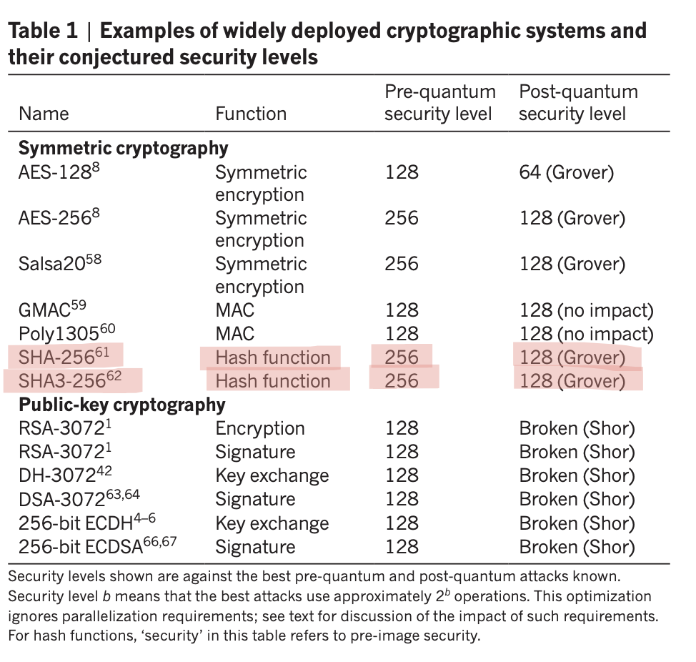

Reference 2: Amy et al., SAC 2016
This paper calculated the actual quantum resources needed to attack SHA-256 on a real fault-tolerant quantum computer.
- Attacking SHA-256 requires approximately 2 to the power 166 basic operations including classical processing.
- The paper concludes: the decrease in the number of bits of security will likely be limited.
- SHA-256 is not practically breakable by any foreseeable quantum hardware.
Citation: Amy et al. Estimating the cost of generic quantum pre-image attacks on SHA-2 and SHA-3. SAC 2016. eprint.iacr.org/2016/992
Reference 2: Amy et al., SAC 2016, Section 8 Conclusion
SHA-256 attack costs 2 to the 166 operations. Not practically breakable.
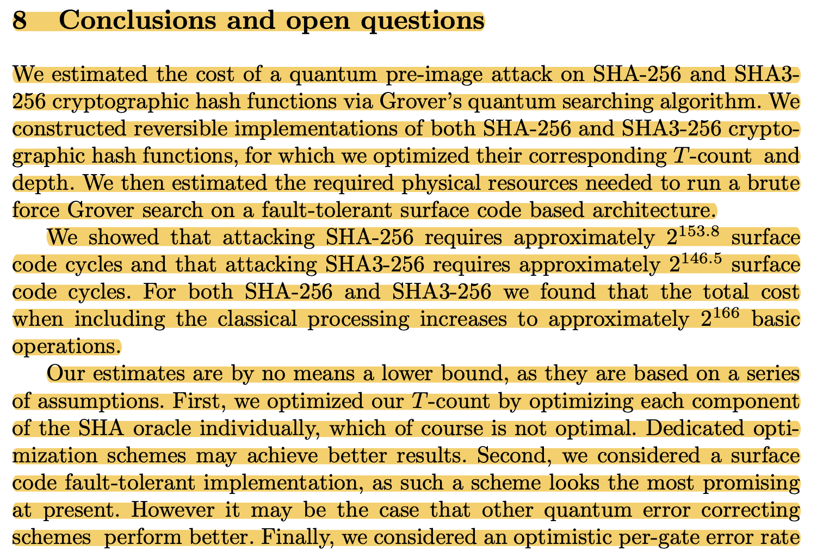

Reference 3: NIST SP 800-208 (Official US Government Standard, 2020)
Section 1 of this official standard states two things in one paragraph:
- On ECC: All of the digital signature schemes specified in FIPS 186 will be broken if large-scale quantum computers are ever built.
- On hash functions: It is believed that the security of hash functions will not be broken by the development of large-scale quantum computers.
Citation: NIST SP 800-208, October 2020. nvlpubs.nist.gov/nistpubs/SpecialPublications/NIST.SP.800-208.pdf
Reference 3: NIST SP 800-208, Section 1 Introduction
Official US standard: ECC will be broken. Hash functions will not be broken.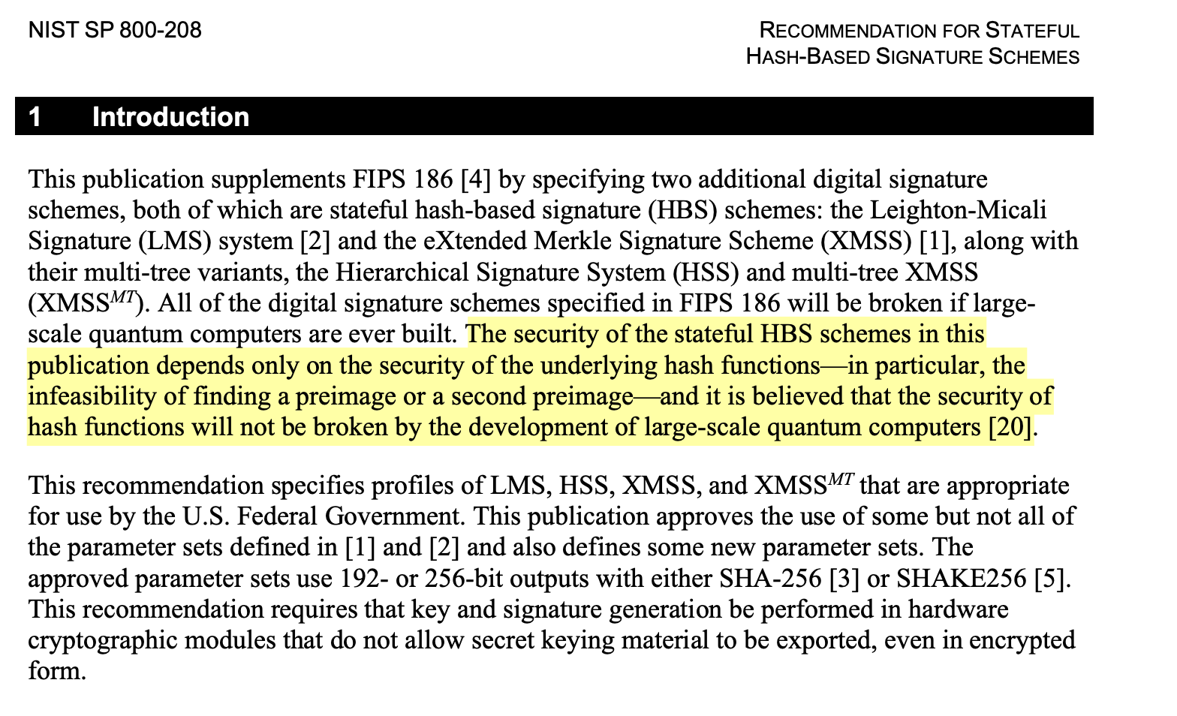

Reference 4: Roetteler et al., Microsoft Research, ASIACRYPT 2017
This paper from Microsoft Research calculated the exact quantum resources needed to break specific ECC curves using Shor's algorithm.
- Breaking the P-256 curve (similar in size to BN254 used in KZG and Artemis) requires approximately 2,330 logical qubits.
- The paper notes that ECC is an easier target than RSA for quantum computers.
- You cannot fix ECC by increasing key size. It will always be vulnerable to Shor's algorithm.
Citation: Roetteler, Naehrig, Svore, Lauter. ASIACRYPT 2017. eprint.iacr.org/2017/598

Reference 4: Roetteler et al., ASIACRYPT 2017, Abstract
Shor's breaks ECC specifically. Approximately 2,330 qubits needed for P-256.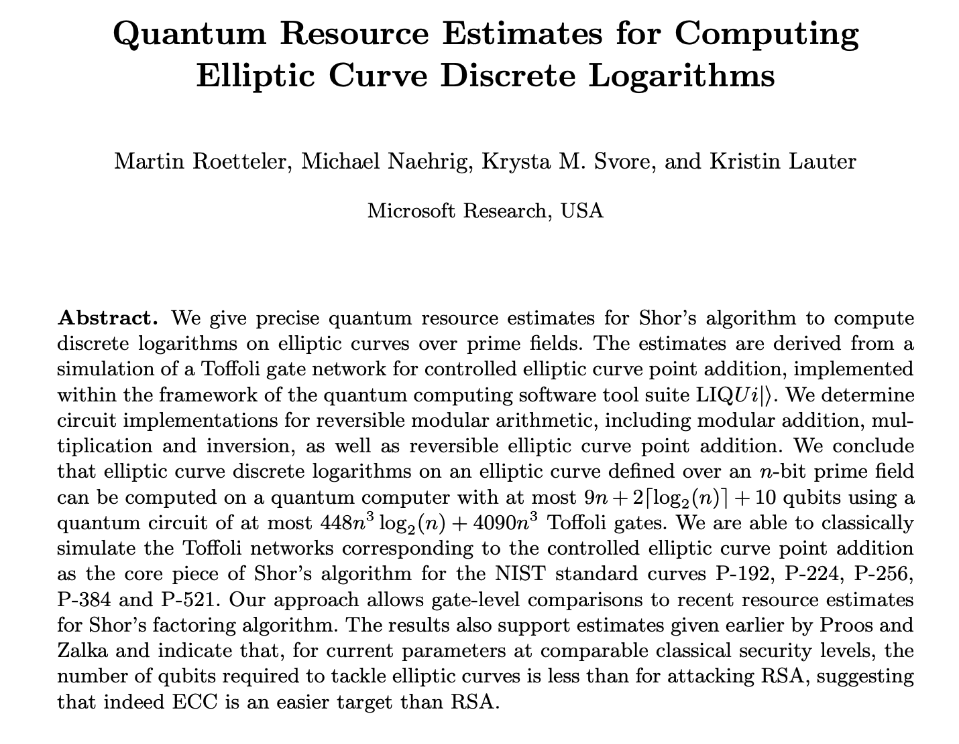

The Quantum Threat: Grover's Algorithm
There are two quantum algorithms relevant to this work. Shor's algorithm breaks ECC. Grover's algorithm partially weakens hash functions.
 | Shor's Algorithm | Grover's Algorithm
What it attacks | ECC and RSA | Hash functions and symmetric encryption
Severity | Complete break.  ECDLP solved in efficient time.  Zero security remains for ECC. | Partial weakening only.  For a 256-bit hash, security drops to 128 bits.  Not a complete break.
Impact on KZG | Fatal.  Shor's recovers secret tau from public SRS.  All three ECC components collapse. | Not applicable.  KZG does not use hash functions.  KZG is already broken by Shor's first.
Impact on FRI + Poseidon | None.  FRI has no ECC. No group structure for Shor's to exploit. | Minor only.  Grover's reduces Poseidon security from 256 bits to 128 bits.  128-bit security is still acceptable by current NIST standards.  Fix: use Poseidon with parameters targeting 256-bit post-quantum security.

Summary: Shor's completely breaks KZG. Grover's only partially weakens hash functions. After replacing KZG with FRI and Poseidon, the only remaining quantum concern is Grover's, which reduces security from 256 to 128 bits. This is manageable and acceptable.
The Research Gap
- Post-quantum polynomial commitment tools exist (Cini et al., SmallWood, FRI)
- Post-quantum proof systems exist (LatticeFold, zk-STARKs)
- The zkML field acknowledges post-quantum security is needed (Survey arXiv:2502.18535)
- Apollo cannot be made post-quantum due to its dependence on KZG pairings
What does not exist: A post-quantum instantiation of the Artemis CP-SNARK pipeline for zkML inference verification. Artemis improves upon all prior zkML proof systems by an order of magnitude. Making it post-quantum is necessary and has not been done. This is the research contribution.

Thesis Contribution Statement
The Artemis zkML pipeline uses ECC in three places: the SRS generation (KZG trusted setup), the polynomial commitment, and the verification check based on ECC pairings. All three are broken by Shor's algorithm through recovery of the secret trapdoor tau. Since Artemis is designed to work with any compatible polynomial commitment tool, we propose replacing KZG with a hash-based commitment scheme using FRI and Poseidon hashing. This eliminates all three ECC dependencies simultaneously, without modifying the Artemis CP-SNARK protocol structure. To our knowledge, this is the first post-quantum instantiation of a Commit-and-Prove SNARK for zkML inference verification.
References
[1] Bernstein and Lange. Post-quantum cryptography. Nature 549, 188 to 194 (2017). doi:10.1038/nature23461
[2] Amy et al. Estimating the cost of generic quantum pre-image attacks on SHA-2 and SHA-3. SAC 2016. eprint.iacr.org/2016/992
[3] NIST SP 800-208. Recommendation for Stateful Hash-Based Signature Schemes. October 2020.
[4] Roetteler, Naehrig, Svore, Lauter. Quantum Resource Estimates for Computing Elliptic Curve Discrete Logarithms. ASIACRYPT 2017. eprint.iacr.org/2017/598
[5] Lycklama et al. Artemis: Efficient Commit-and-Prove SNARKs for zkML. arXiv:2409.12055, 2024.
[6] Nainwal et al. A Comparative Analysis of zk-SNARKs and zk-STARKs. arXiv:2512.10020, 2025.
[7] Ben-Sasson et al. Fast Reed-Solomon based commitment system. ICALP 2018.
[8] Grassi et al. Poseidon: A New Hash Function for Zero-Knowledge Proof Systems. USENIX 2021.
[9] Cini, Malavolta, Nguyen, Wee. Polynomial Commitments from Lattices: Post-Quantum Security, Fast Verification and Transparent Setup. CRYPTO 2024. eprint.iacr.org/2024/281
[10] Boneh and Chen. LatticeFold: A Lattice-Based Folding Scheme and its Applications to Succinct Proof Systems. 2024. eprint.iacr.org/2024/257
[11] Feneuil and Rivain. SmallWood: Hash-Based Polynomial Commitments and Zero-Knowledge Arguments. 2025. eprint.iacr.org/2025/1085
[12] Survey on ZKML. A Survey of Zero-Knowledge Proof Based Verifiable Machine Learning. arXiv:2502.18535, February 2025.
[13] Moody et al. Transition to Post-Quantum Cryptography Standards. NIST IR 8547 (Initial Public Draft), November 2024. https://doi.org/10.6028/NIST.IR.8547.ipd

